**1025866 Rev C**

**Firmware Support Manual (FSM) for DAIRCM II Control Processor OMAP**

Change Record

|  |  |  |  |  |
| --- | --- | --- | --- | --- |
| **Originator** | **Rev** | **Date** | **CR #** | **Description Of Change** |
| Jim Swartzendruber | 50 | 05/17/2017 | XXXXX | Initial Release. Risk Reduction Flight Build 0.6b* |
| Jim Swartzendruber | 51 | 05/25/2017 | XXXXX | Risk Reduction Flight Build 0.6c |
| Will Hannah | 52 | 07/06/17 | XXXXX | Internal Release with additional features. Version 0.7A |
|  |  |  |  |  |
|  |  |  |  |  |

Table of Contents

1 Scope 5

1.1 Identification 6

1.2 System Overview 7

1.3 Document Overview 8

2 Referenced Documents 9

3 Firmware Programming Instructions 10

3.1 CP OMAP Flash 11

3.1.1 Description of Pre-Programmed Device 11

3.1.2 Software to be Programmed into the Device 11

3.1.3 Programming Equipment 11

3.1.4 Programming Software 11

3.1.5 Programming Procedures 12

3.1.6 Installation and Repair Procedures 19

3.1.7 Vendor Information 19

4 Notes 20

4.1 TI Code Composer Studio C6000 Compiler Selection 20

4.2 Emulator Selection and Configuration 23

Appendix A Version Listing 32

List of Figures

Figure 1 – Launch Code Composer Studio 12

Figure 2 – Starting Debug Session 13

Figure 3- Wake DSP Processor 14

Figure 4- Connect to DSP Processor 14

Figure 5 – Load NORWriter_DSP 15

Figure 6 – Load NORWriter_DSP.out 15

Figure 7 – Start NORWriter_DSP execution 16

Figure 8 – Enter the binary download package 16

Figure 9 – Binary programming messages 17

Figure 10 – ASP Control GUI 17

Figure 11 – ASP Control GUI (Connected) 18

Figure 12 – ASP Control GUI (Misc Regs Tab) 18

Figure 13 – ASP Control GUI (DSP Version) 19

List of Tables

Table 1 - Firmware and Software Components 6

# Scope

This Firmware Support Manual (FSM) describes the initial programming process for the DAIRCM II Control Processor OMAP to support the manufacture and test of DAIRCM II Control Processors.

## Identification

Table - Firmware and Software Components

|  |  |  |  |  |  |
| --- | --- | --- | --- | --- | --- |
| Component | Part Number | File Name | Date | File Size | Checksum CRC32 |
| CP OMAP | OMAPL138EZWTA3 | BareMetalDSP.out | 6/01/2017 | 20KB |  |
|  |  | omap_arm.out | 6/01/2017 | 3,700 KB |  |
|  |  | omap_arm_0B0D0007.bin | 6/01/2017 | 360 KB | 30FCA0DE |
|  |  | [*https://davms120130.core.drs.master/svn/ASP_DSP/tags/build07A*](https://davms120130.core.drs.master/svn/ASP_DSP/tags/build07A) | | | |
|  |  |  |  |  |  |
|  |  | NORWriter_DSP.out | 5/17/2017 | 297 KB | B38B23E7 |
|  |  | NORWriter_DSP.zip | 5/18/2017 | 909 KB | FC75106F |
|  |  | [*https://davms120130.core.drs.master/svn/ASP_DSP/tags/build07A*](https://davms120130.core.drs.master/svn/ASP_DSP/tags/build07A) | | | |

## System Overview

The DAIRCM II Control Processor OMAP is part of larger aircraft survivability platform. This processor provides a state-driven interface between DAIRCM II Control Processor and external appliances to report threats, make operation selections, extract position and time from multiple GPS/INS devices, make laser port selection, and deploy CMDS flares.

Rev B is for a Risk Reduction Flight incorporating Build 0.6c firmware to provide MIL-STD-1553B bus communications to the GPS/INS device, and to report initialization sequence and BIT faults on the AAR‑47 Control Indicator. Build 0.6c incorporated changes to operate on a second flight platform.

## Document Overview

The purpose of this document is to provide instructions on how to program the OMAP device on the DAIRCM II Control Processor digital board.

# Referenced Documents

No documents are referenced in this FSM.

# Firmware Programming Instructions

## CP OMAP Flash

The CP OMAP receives MIL-STD-1553B bus communications and provides AAR-47 Control Indicator Menuing, displays and fault indications.

### Description of Pre-Programmed Device

1. The device to be programmed is on the DRS DAIRCM II Control Processor processor board.
2. The following is a description of the firmware device and the devices connected to it:
3. Numonyx PC28F512P30EFA 512 Mbyte parallel flash for Bootstrap, ARM, and DSP images. The images will be used by the following devices:
   1. Texas Instruments OMAP L-138 DSP/ARM
4. The programming of the OMAP must be done at room temperature on a static protected mat.

### Software to be Programmed into the Device

The DAIRCM II Control Processor OMAP programming files are located in PDMLink. For initial programming, use the “NORWriter_DSP” Code Composer Studio project contained under the secondary attachment of this document. For in-system programming, use the “*.bin” file.

### Programming Equipment

The following equipment is required to reprogram the device:

1. Laptop computer
   1. CCS 5.5 software with updates installed
   2. Blackhawk USB-560m 20-pin JTAG emulator
   3. ASP Control GUI, Version 2017.4.25.625 or later
2. Control Processor digital board with power supply & chassis

### Programming Software

*The following software is required to program the device:*

* ***Code Composer Studio ver. 5.5***

*This software tool will JTAG the DSP/ARM code into the device. It will allow the code to run on the OMAP to program the binary into flash memory.*

* ***ASP Control GUI ver. 2017.5.16.1120***

*This software tool communicate with the Control Processor over Ethernet to query firmware version numbers. A valid Ethernet Address is required.*

### Programming Procedures

*Unzip* ***NORWriter_DSP.zip*** *Code Composer Studio project to* ***C:\ASP_DSP***

*Copy* ***omap_arm_0B320006.bin*** *to* ***C:\ASP_BIN\NORWriter_DSP***

*Open Code Composer Studio by clicking the icon shown in Figure 2 and select the workspace C:\ASP_DSP. You may also select the workspace by selecting*

*Titlebar : Files : Switch Workspace : Other*

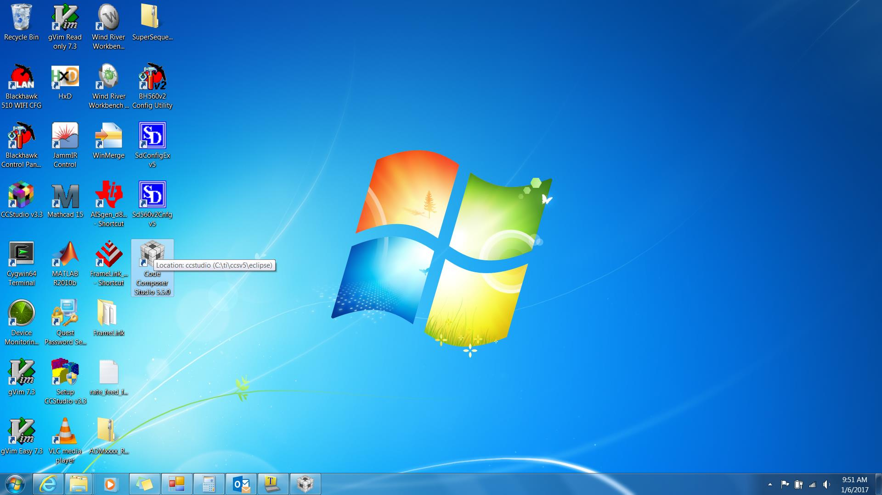

Figure – Launch Code Composer Studio

*Select the “OMAPL138.ccxml” configuration by clicking on the “bug” pulldown menu as shown in Figure 2*

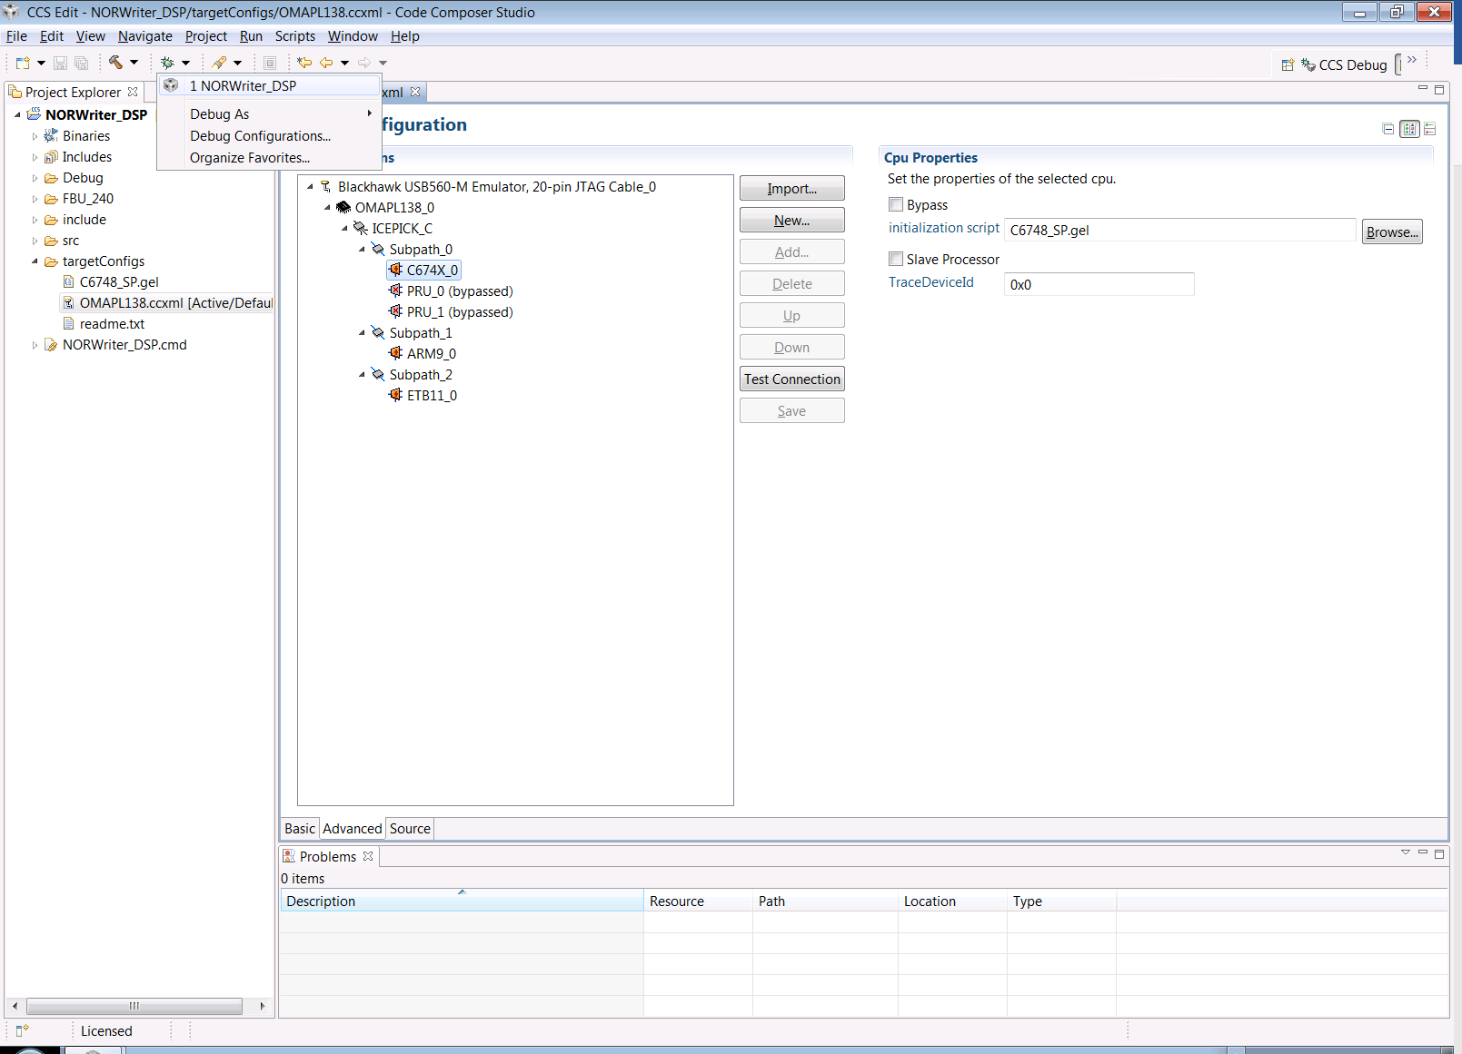

Figure – Starting Debug Session

*Select the eclipse CCS Debug view in the upper right corner of the Eclipse tool (if it does not get selected automatically). In the Debug window, right click on the ARM device and select “Connect Target” as shown in Figure 3. You should observe the GEL script executing in the CONSOLE Tab (bottom window) with no errors.*

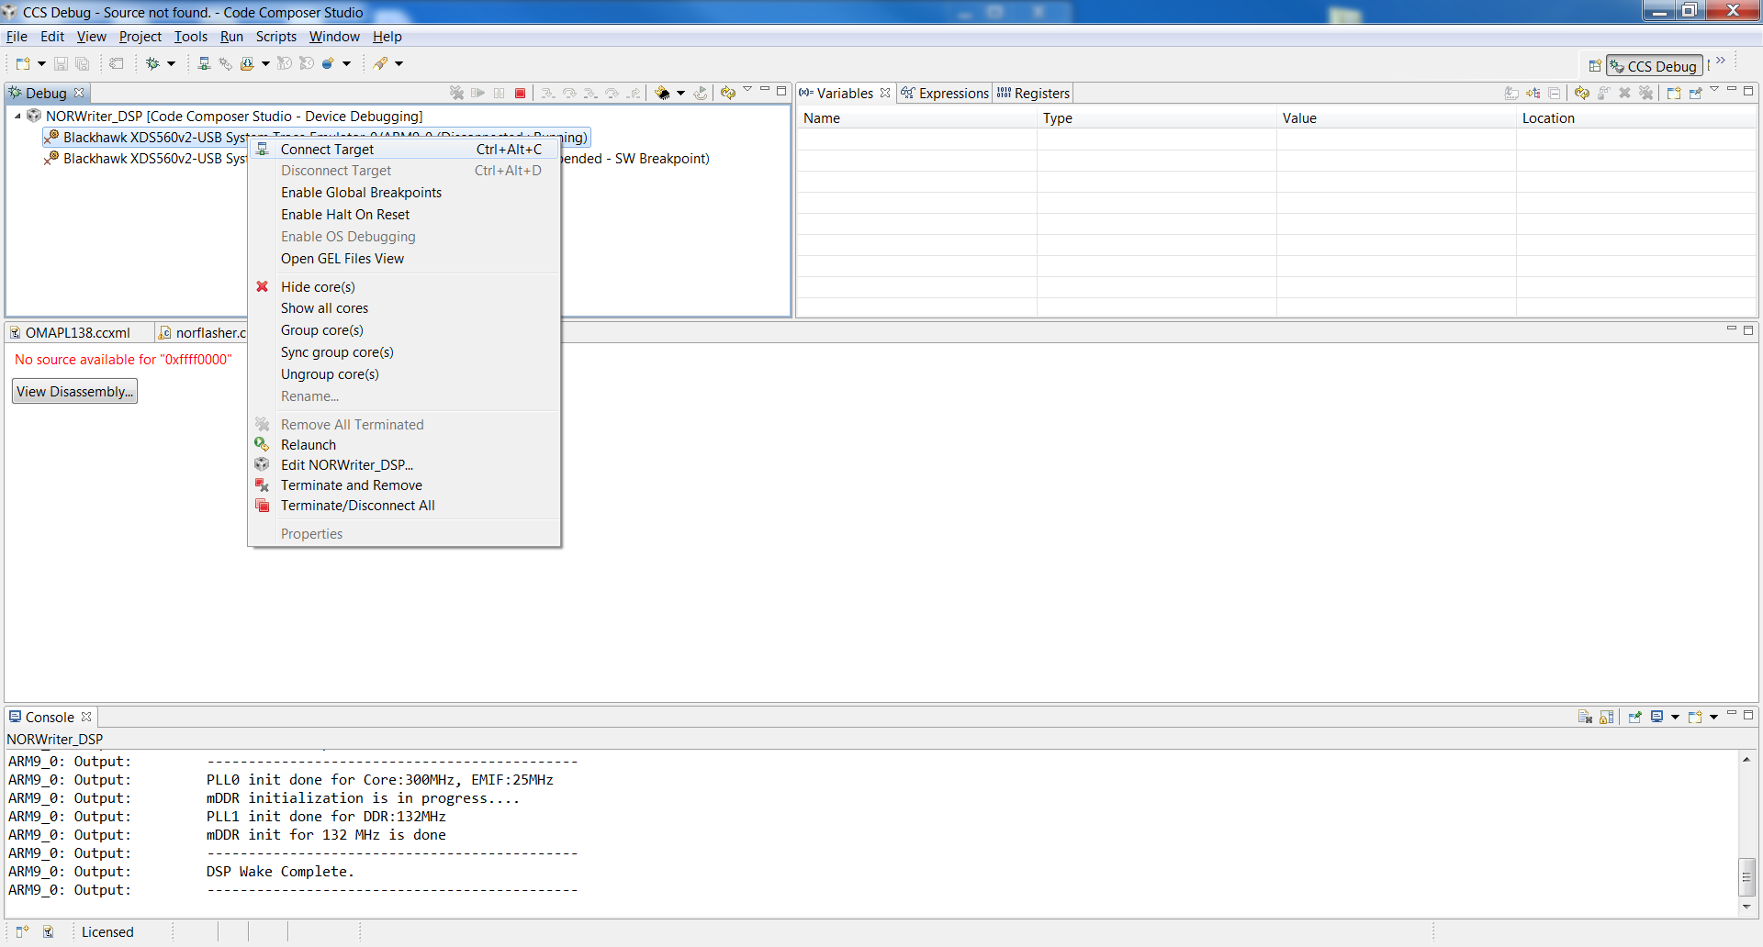

Figure - Wake DSP Processor

*In the Debug window, right click on the C674X device and select “Connect Target” as shown in Figure 4. Again, you should observe the GEL script executing in the CONSOLE Tab (bottom window) with no errors.*

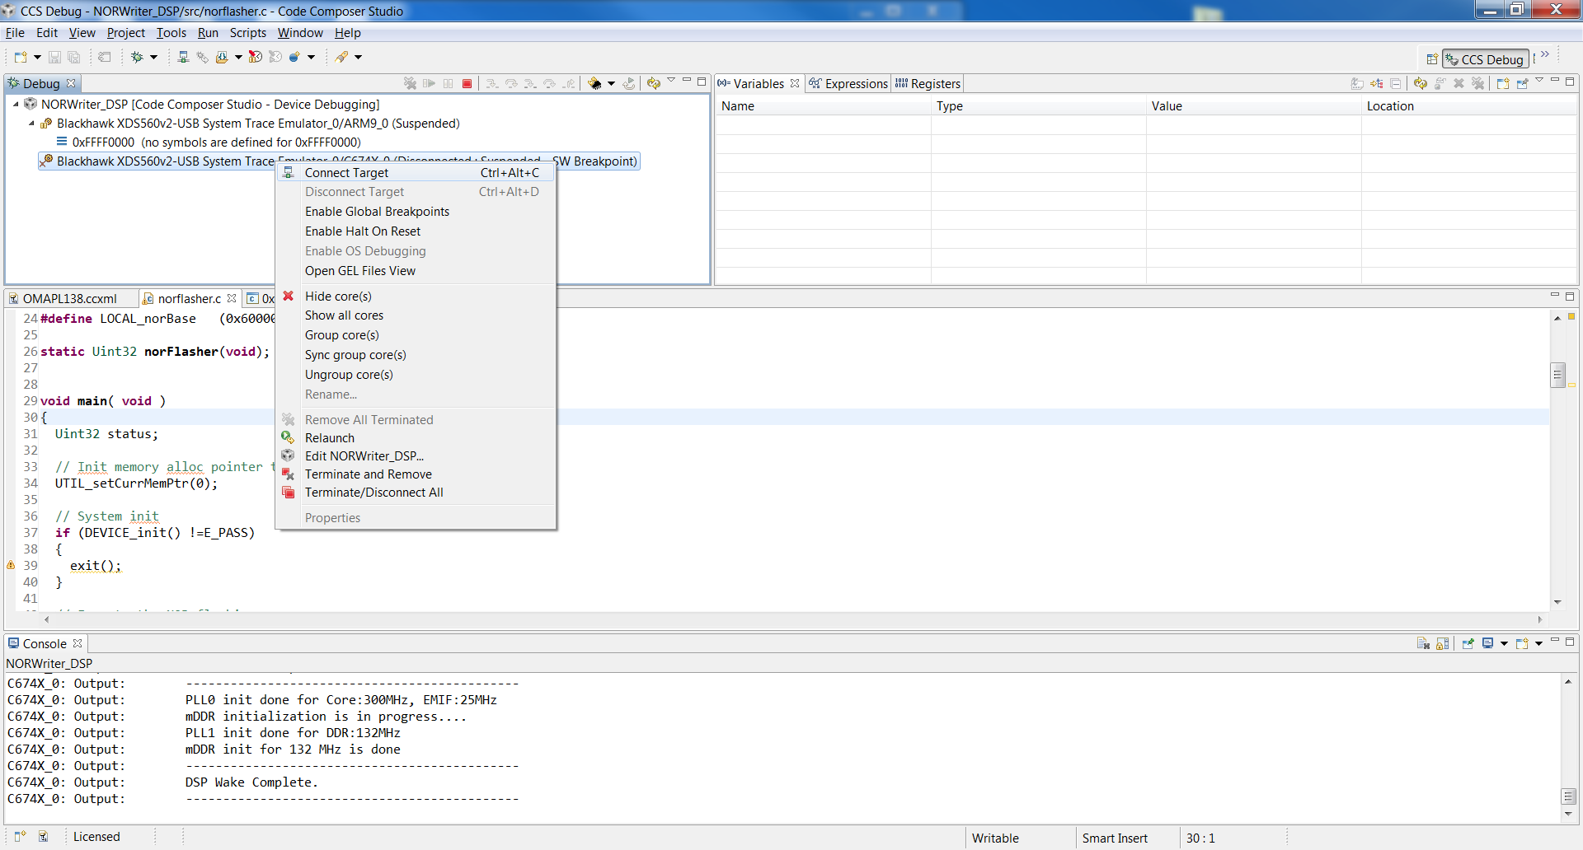

Figure - Connect to DSP Processor

*Click on the Run pull down menu and select Load. Click on the* ***NORWriter_DSP*** *choice as shown in Figure 5. If dimmed, the executable has been loaded into OMAP RAM.*

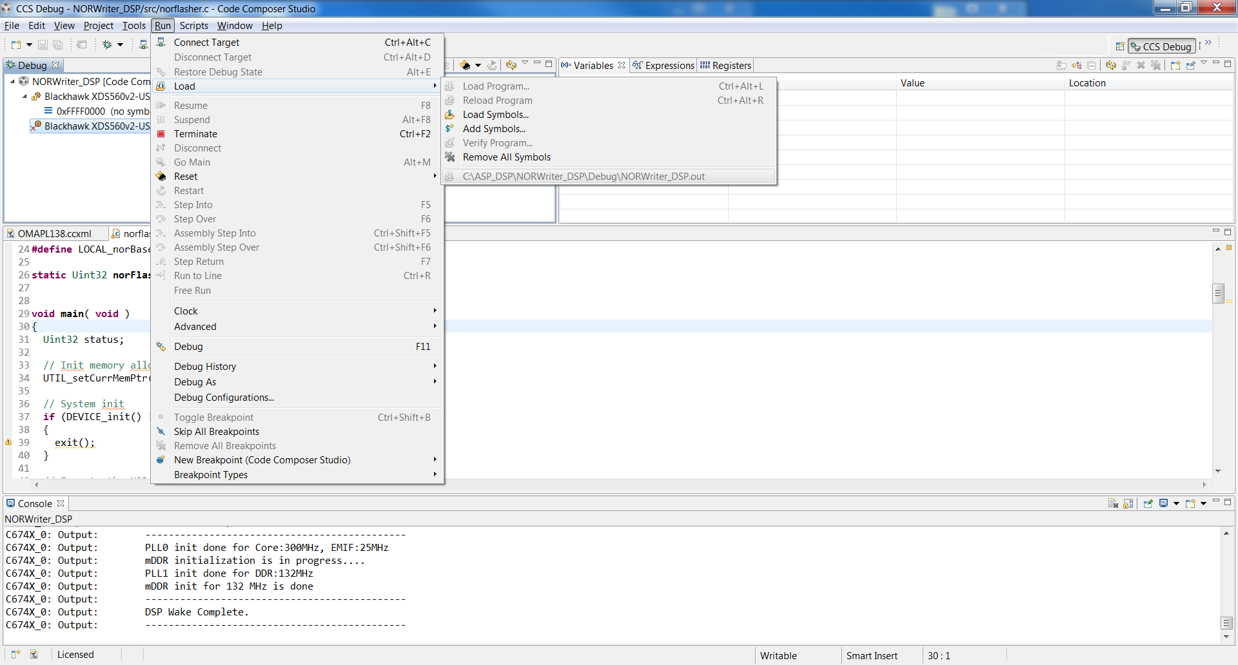

Figure – Load NORWriter_DSP

*Set the breakpoint in the norflasher.c code on line 30 as shown in Figure 6 (set breakpoint by double clicking on the margin next to the line number).*

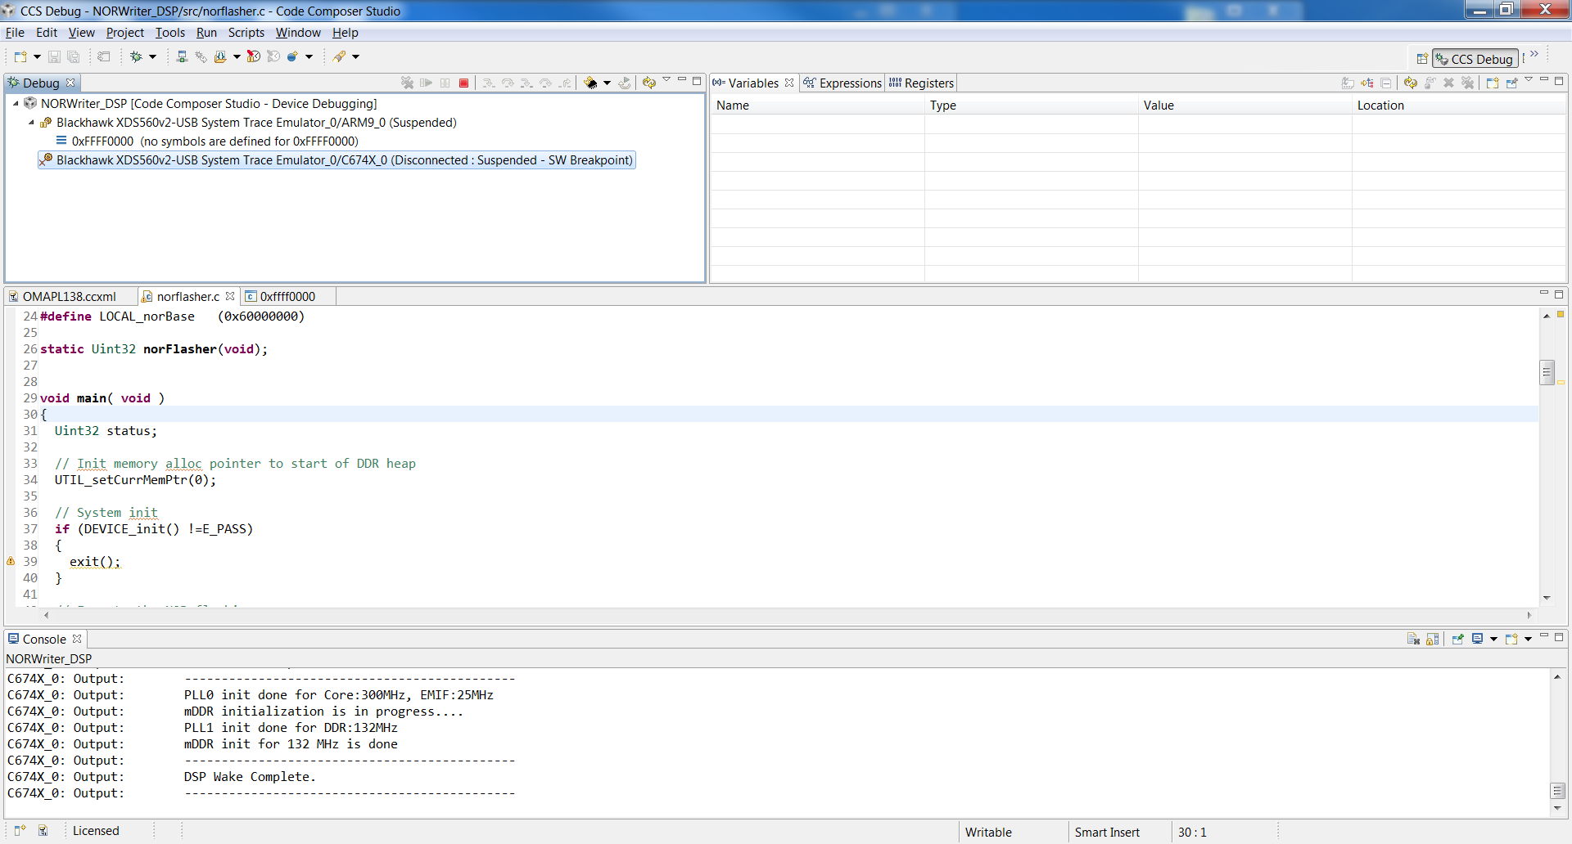

Figure – Load NORWriter_DSP.out

*Click on Titlebar : Run : Resume to start the code running as shown in Figure 7.*

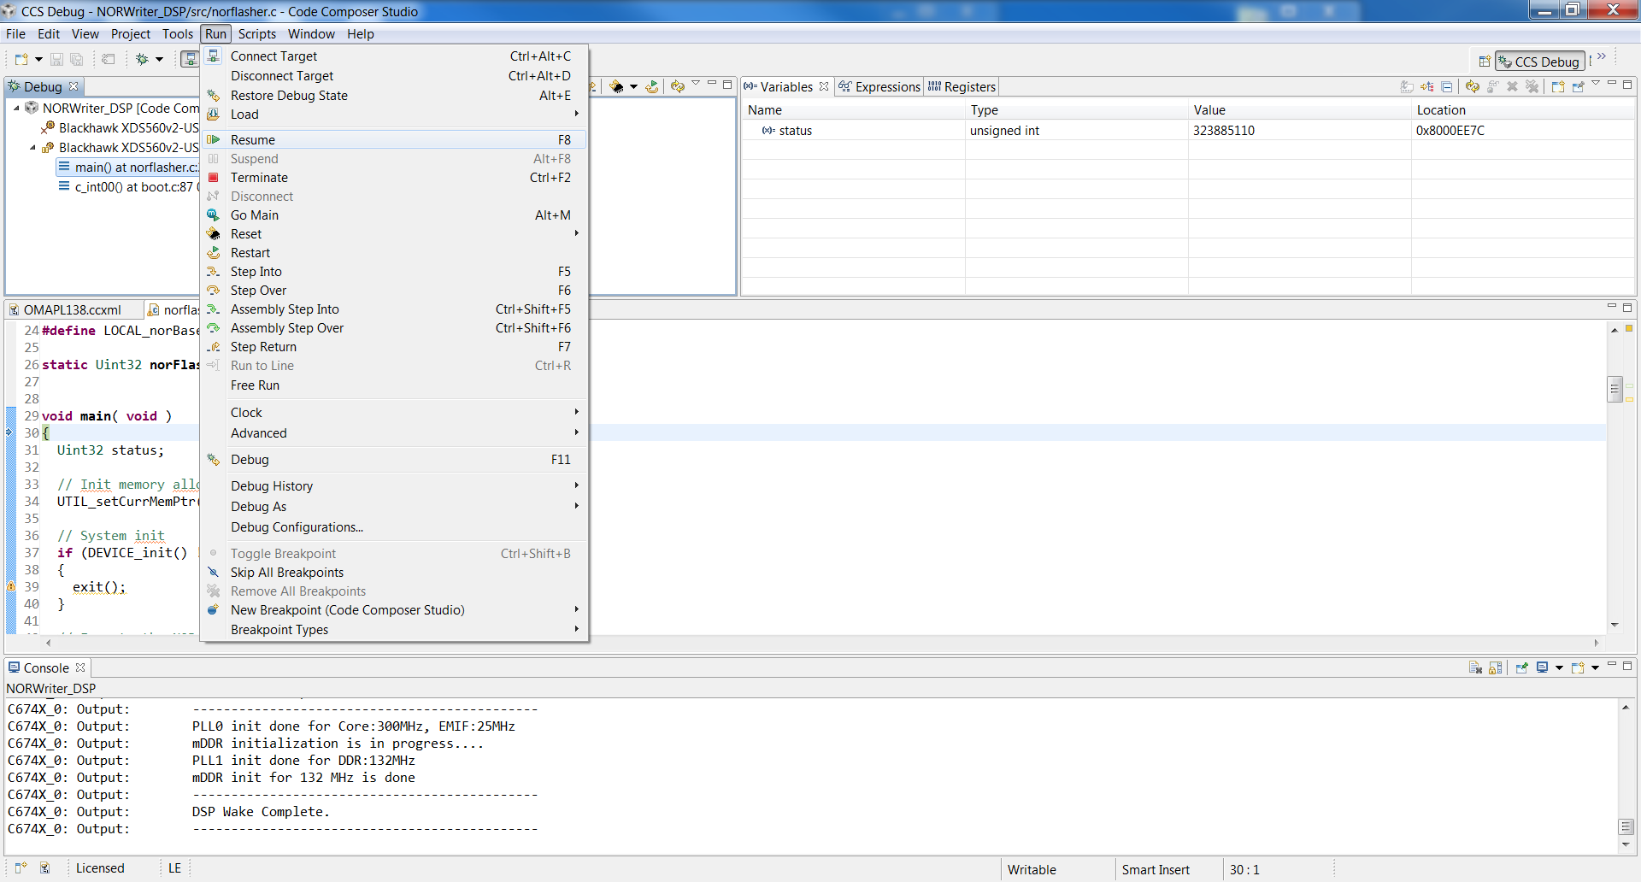

Figure – Start NORWriter_DSP execution

*Watch the CONSOLE Tab and observe the request to “Enter the binary AIS app file name”. Enter C:\ASP_DSP\omap_arm_0B320006.bin, as shown in Figure 8. The binary file is located as a secondary attachment to FSM 1025866.*

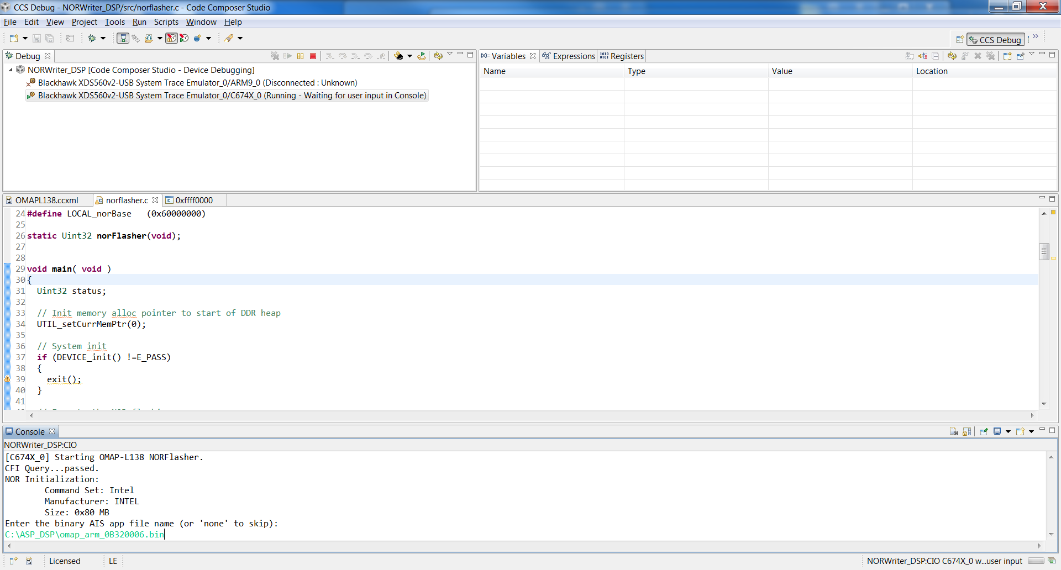

Figure – Enter the binary download package

*The binary download package is loaded into local RAM before programming. Wait two minutes for the download to complete and the CONSOLE Tab shows reprogramming progress. The progress messages are shown in Figure 9.*

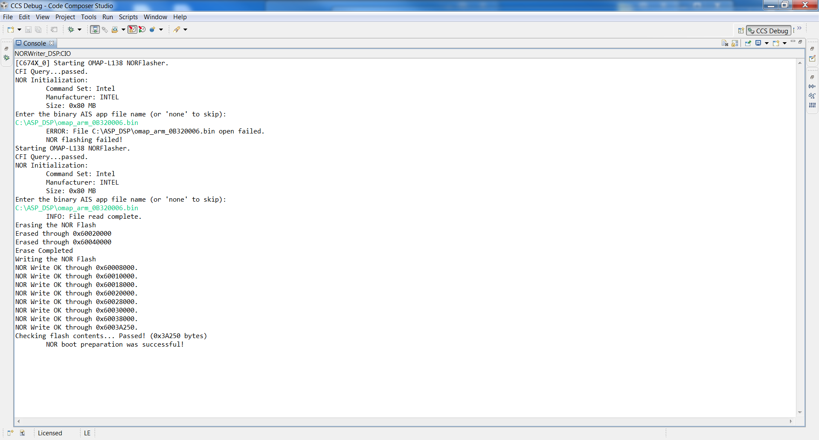

Figure – Binary programming messages

*The OMAP has been successfully reprogrammed. Power cycle the system, or press the RESET button found near the power connectors. Start ASP Control GUI, connect to the CP and query the configuration. Refer to figures 10 thru 13.*

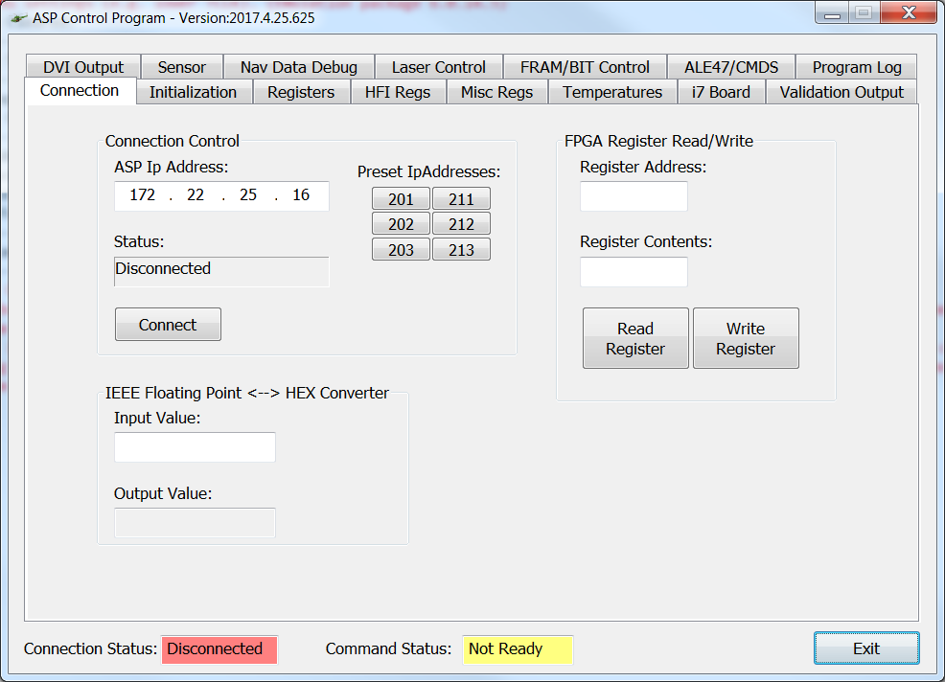

Figure – ASP Control GUI

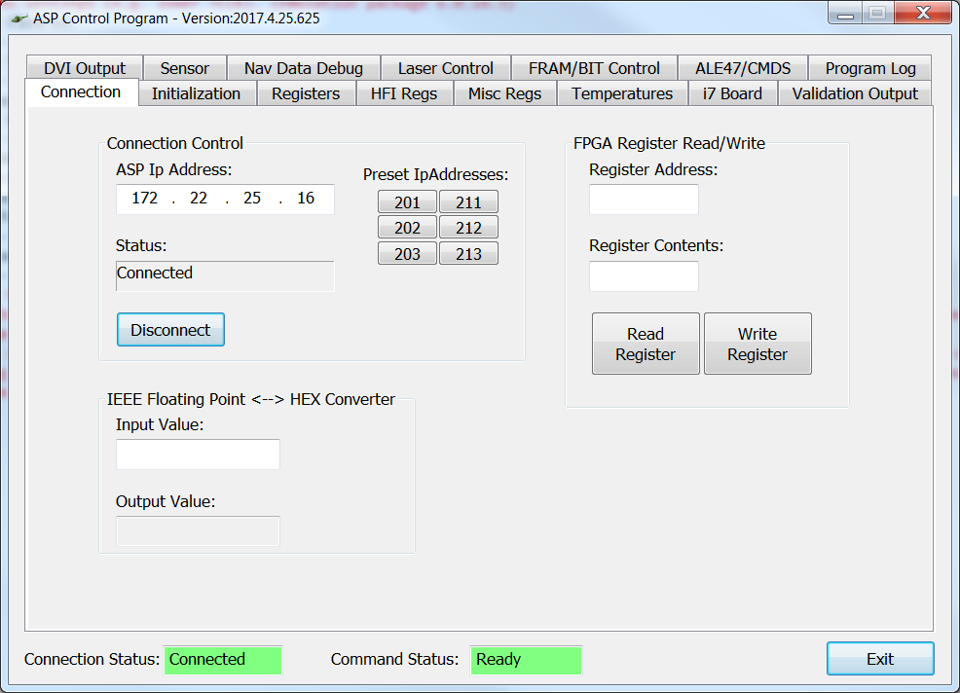

Figure – ASP Control GUI (Connected)

*Select the Misc Regs Tab and then select the Read from FPGA button.*

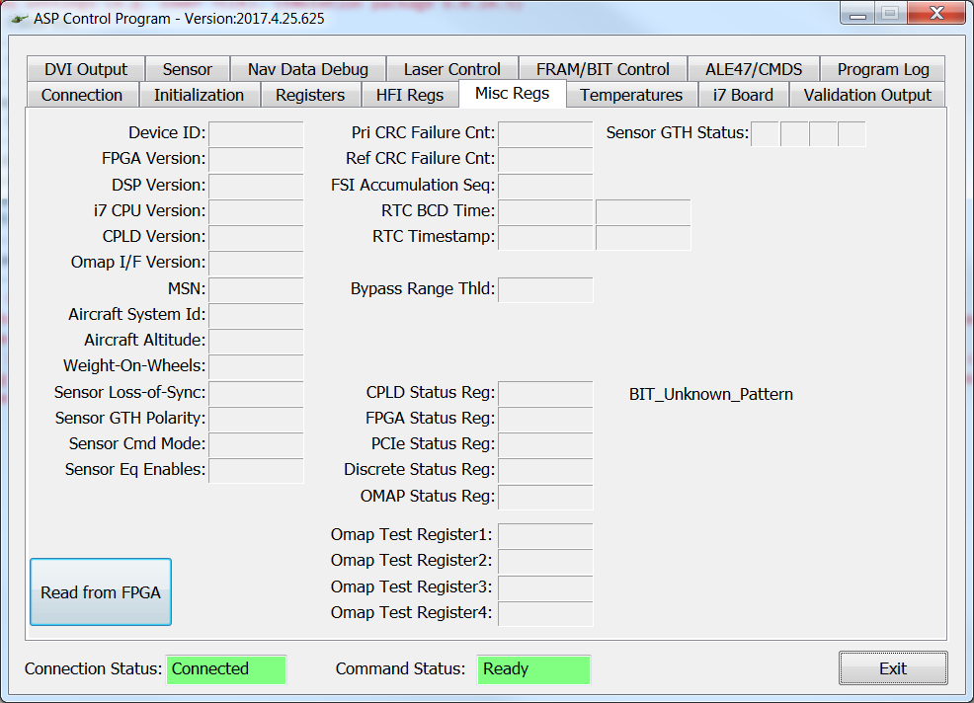

Figure – ASP Control GUI (Misc Regs Tab)

*The OMAP Version is displayed in the DSP Version field.*

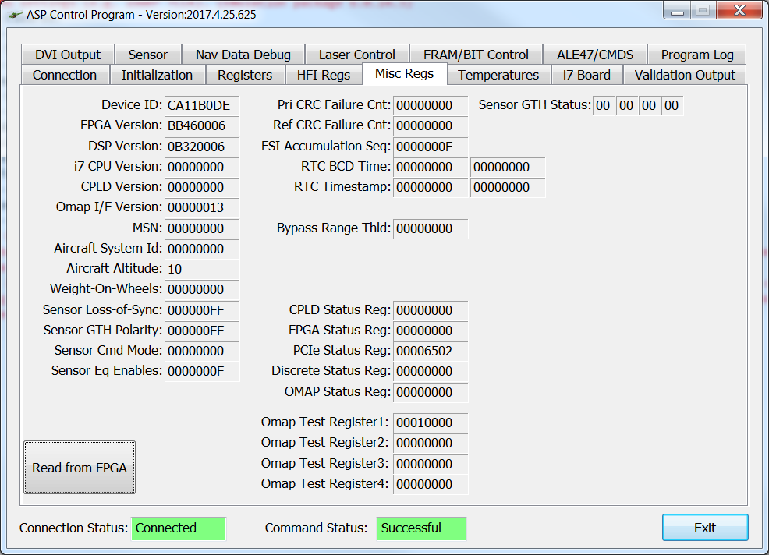

Figure – ASP Control GUI (DSP Version)

#### Manufacturer Programming

### Installation and Repair Procedures

### Vendor Information

# Notes

## TI Code Composer Studio C6000 Compiler Selection

CCS v5.5 must be updated to load the C6000 TI Compiler version 8.1.

*First, select*

*Titlebar : Help : Install New Software…*

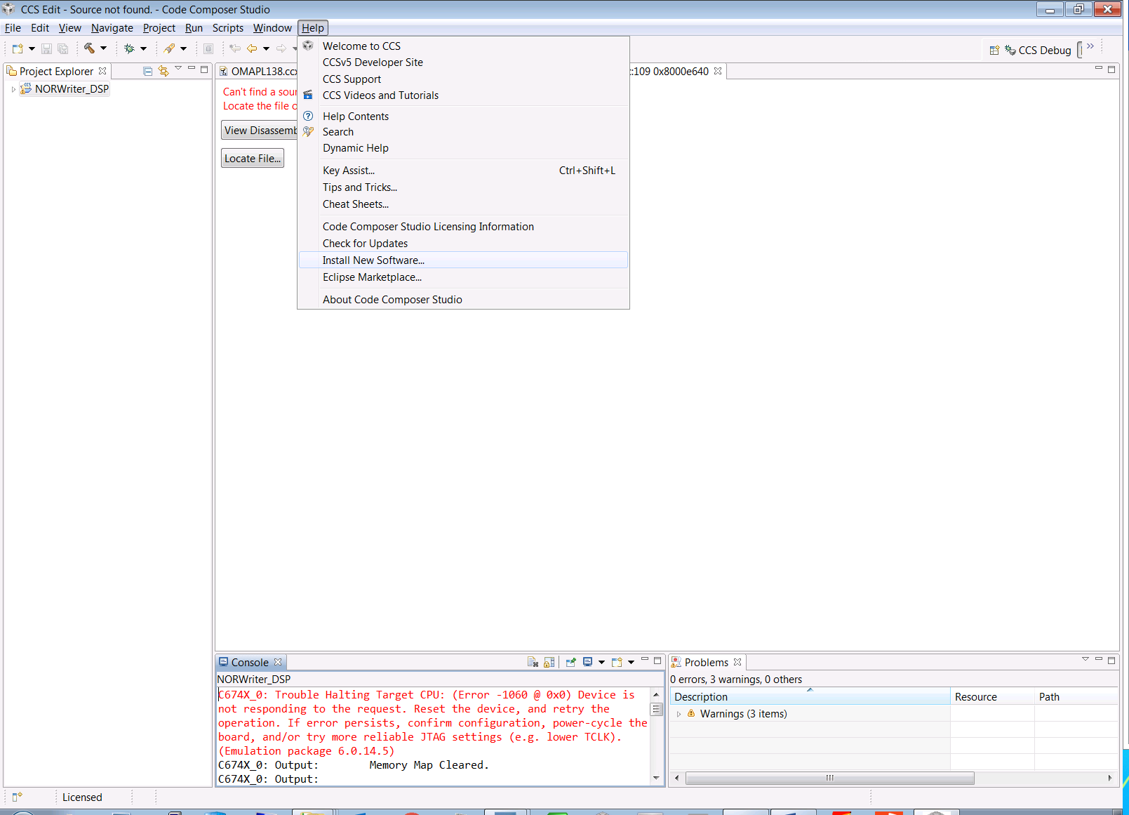

*In the Install Popup window, select the Code Generation Tool Updates site from the dropdown list*

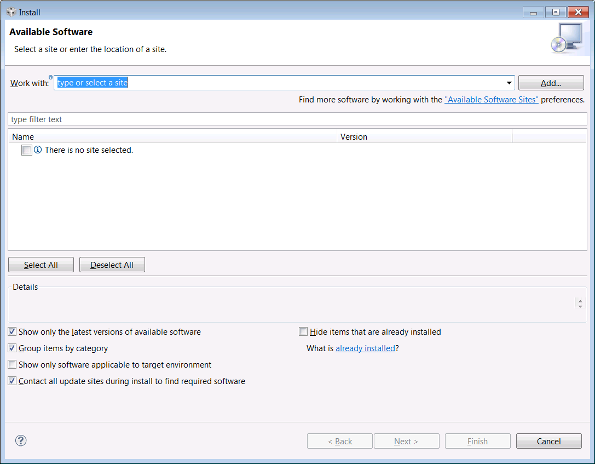

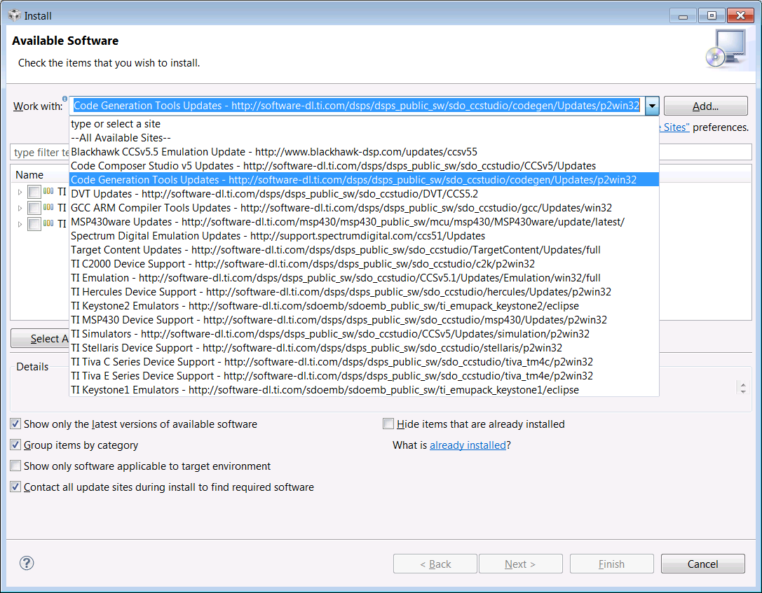

*Enter C6000 in the Search box, and select the C6000 Compiler Tools version 8.1.3*

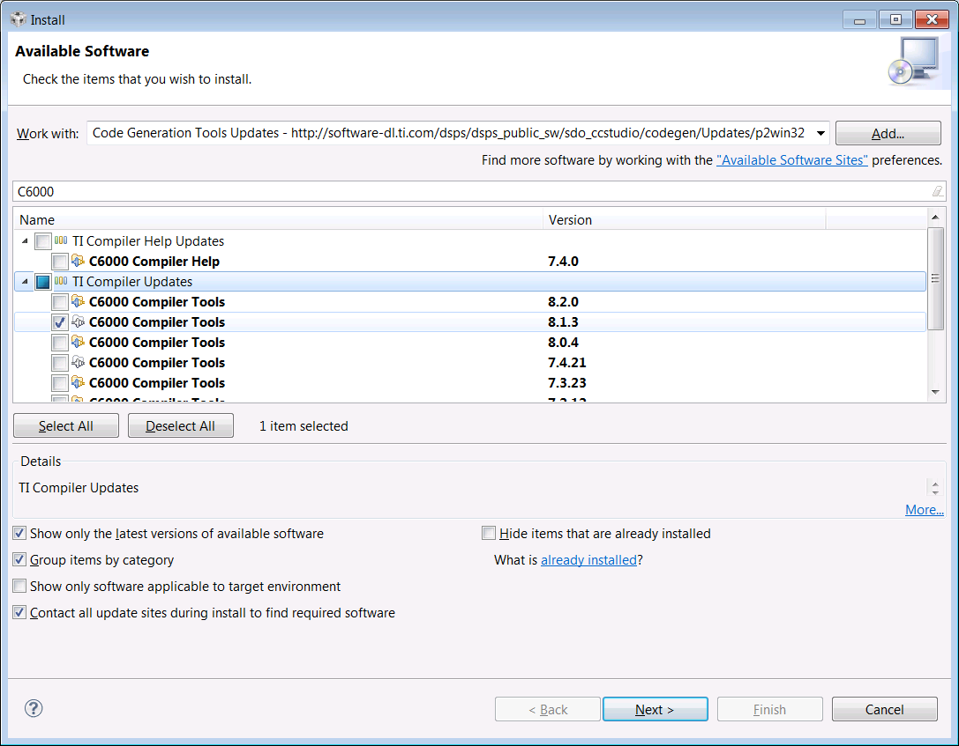

*Select the C6000 Compiler Tools version 8.1.3 and then select the Finish button. The example below has the TI compiler already installed. You will need to accept the license agreement on the next screen.*

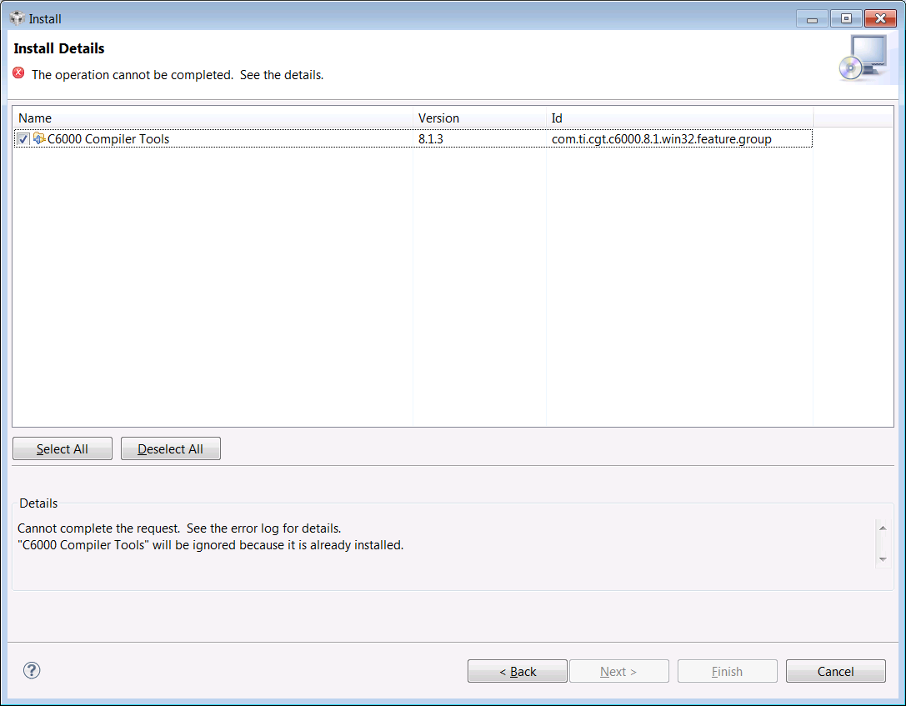

## Emulator Selection and Configuration

The Target Configuration always configures to DEFAULT operation whenever selecting the Blackhawk JTAG Emulator. Follow the instructions below to properly configure the JTAG emulator.

*First, select Project Explorer : NORWriter_DSP Project*

*Right select NORWriter_DSP Project and choose Properties from the popup context menu*

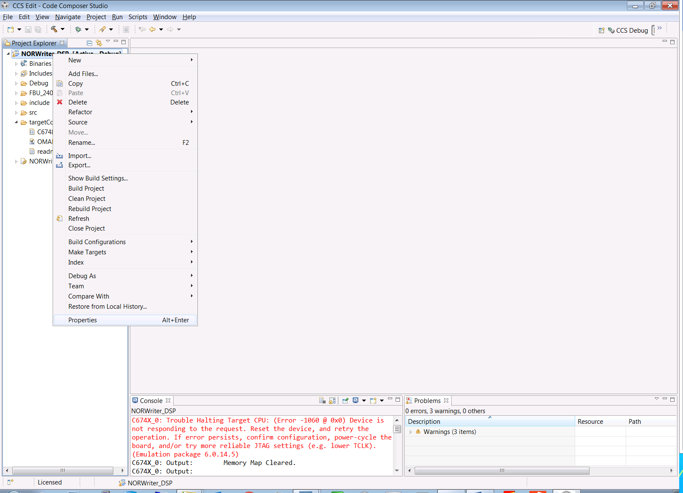

*Select* ***General*** *from the Left Pane, and then select* ***Blackhawk USB560-M, 20 pin JTAG Cable*** *from the connection dropdown*

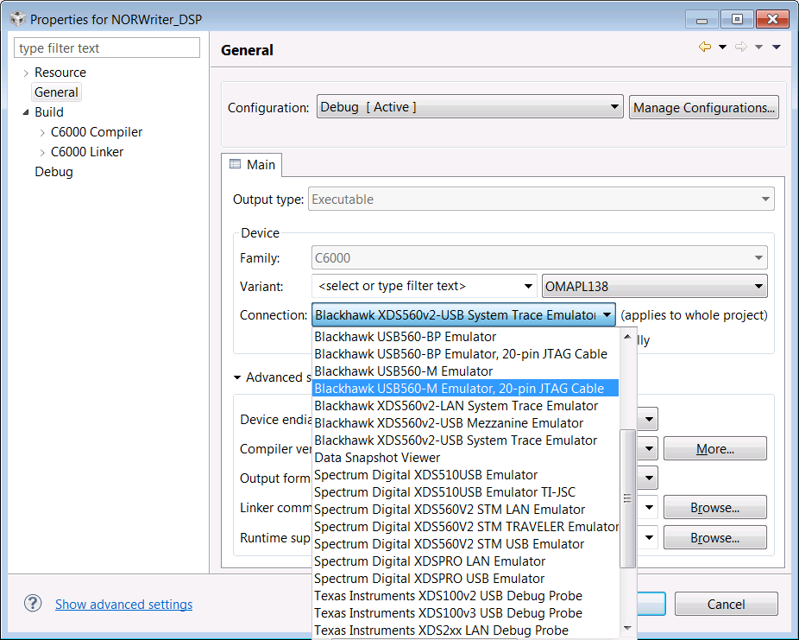

*Select* ***Debug*** *from the Left Pane, and then select* ***Blackhawk USB560-M, 20 pin JTAG/CC74X_0*** *from the device dropdown*

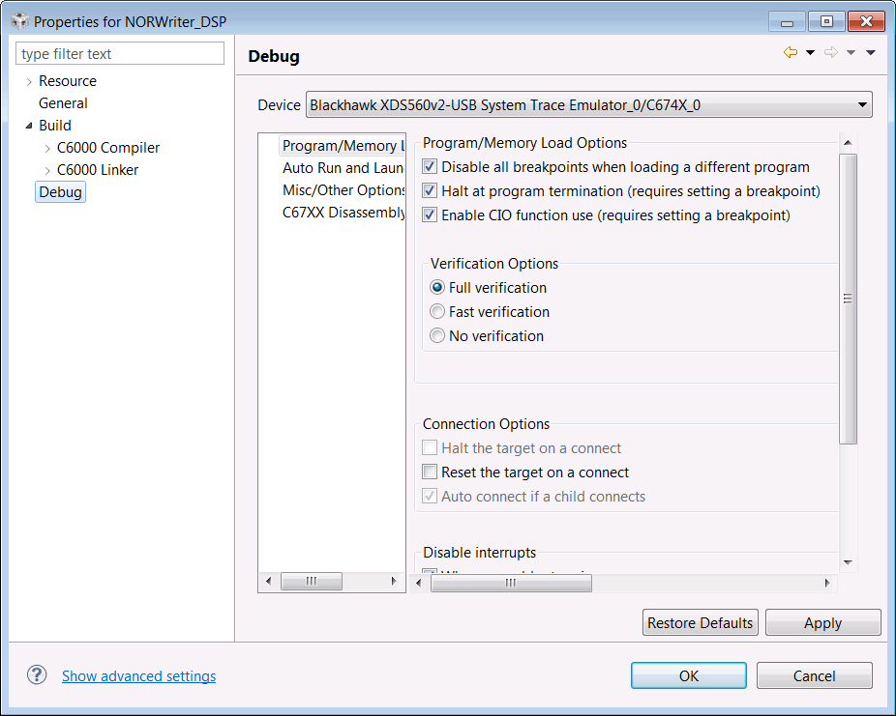

*Expand the Properties Popup to full screen to make the following selections easier.*

*Select Program/Memory Load Options and confirm the following checkboxes are selected. Press Apply button to commit your changes*

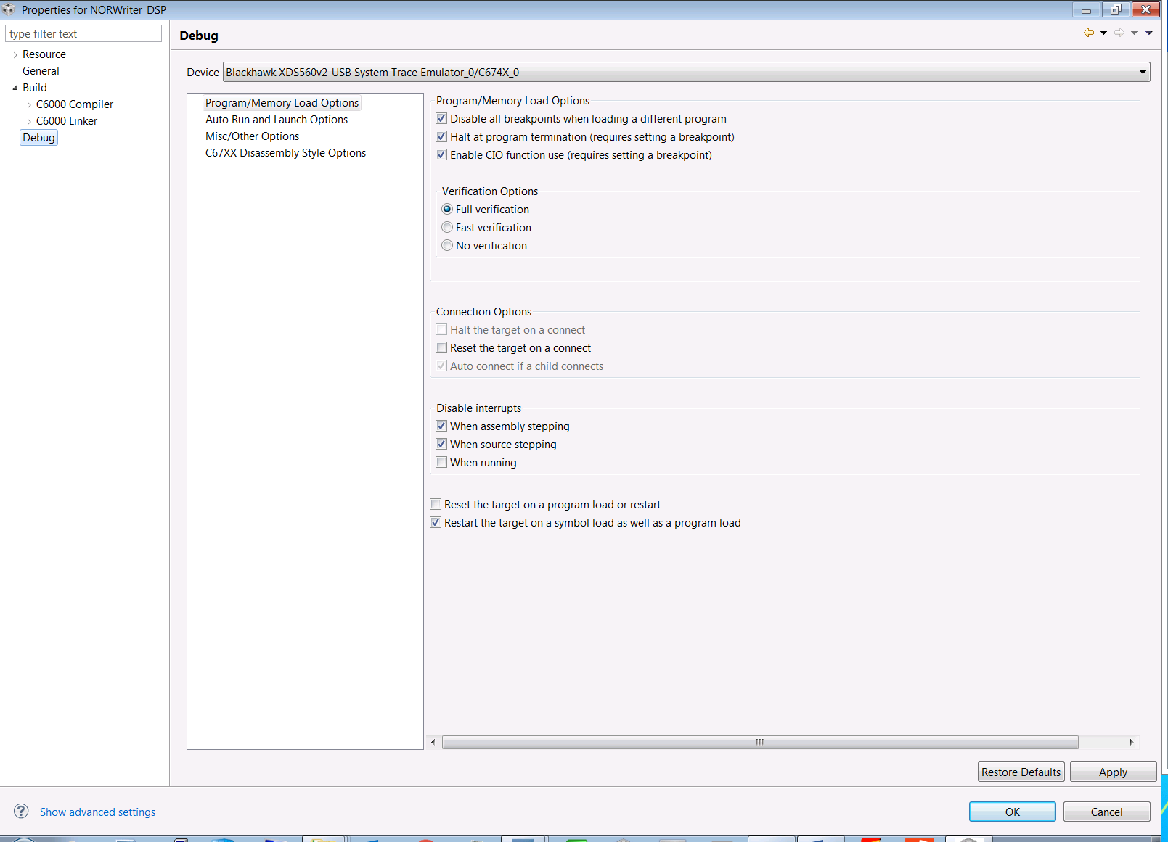

*Select Auto Run and Launch Options and confirm the following checkboxes are selected. Press Apply button to commit your changes. Press OK button to close the popup window.*

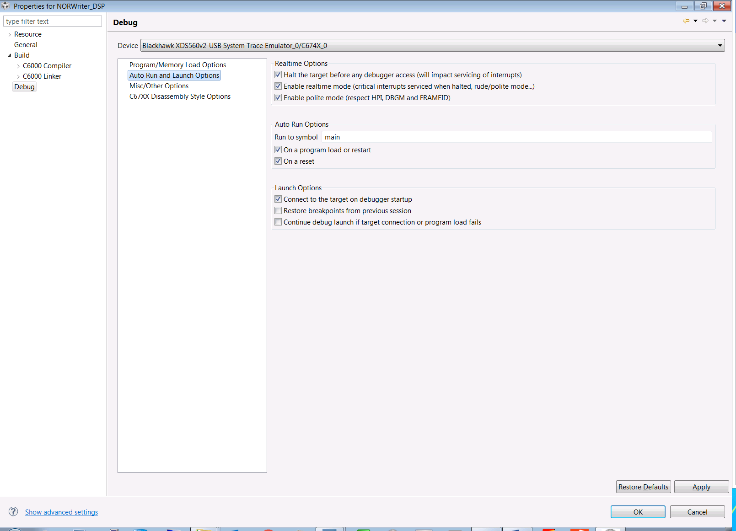

*Open the Target Configuration by selecting*

*Project Explorer : NORWriter_DSP : targetConfigs : OMAPL138.ccxml*

*Select the Test Connection to confirm JTAG Emulator operation*

*Select the Advanced Setup : Target Configuration link*

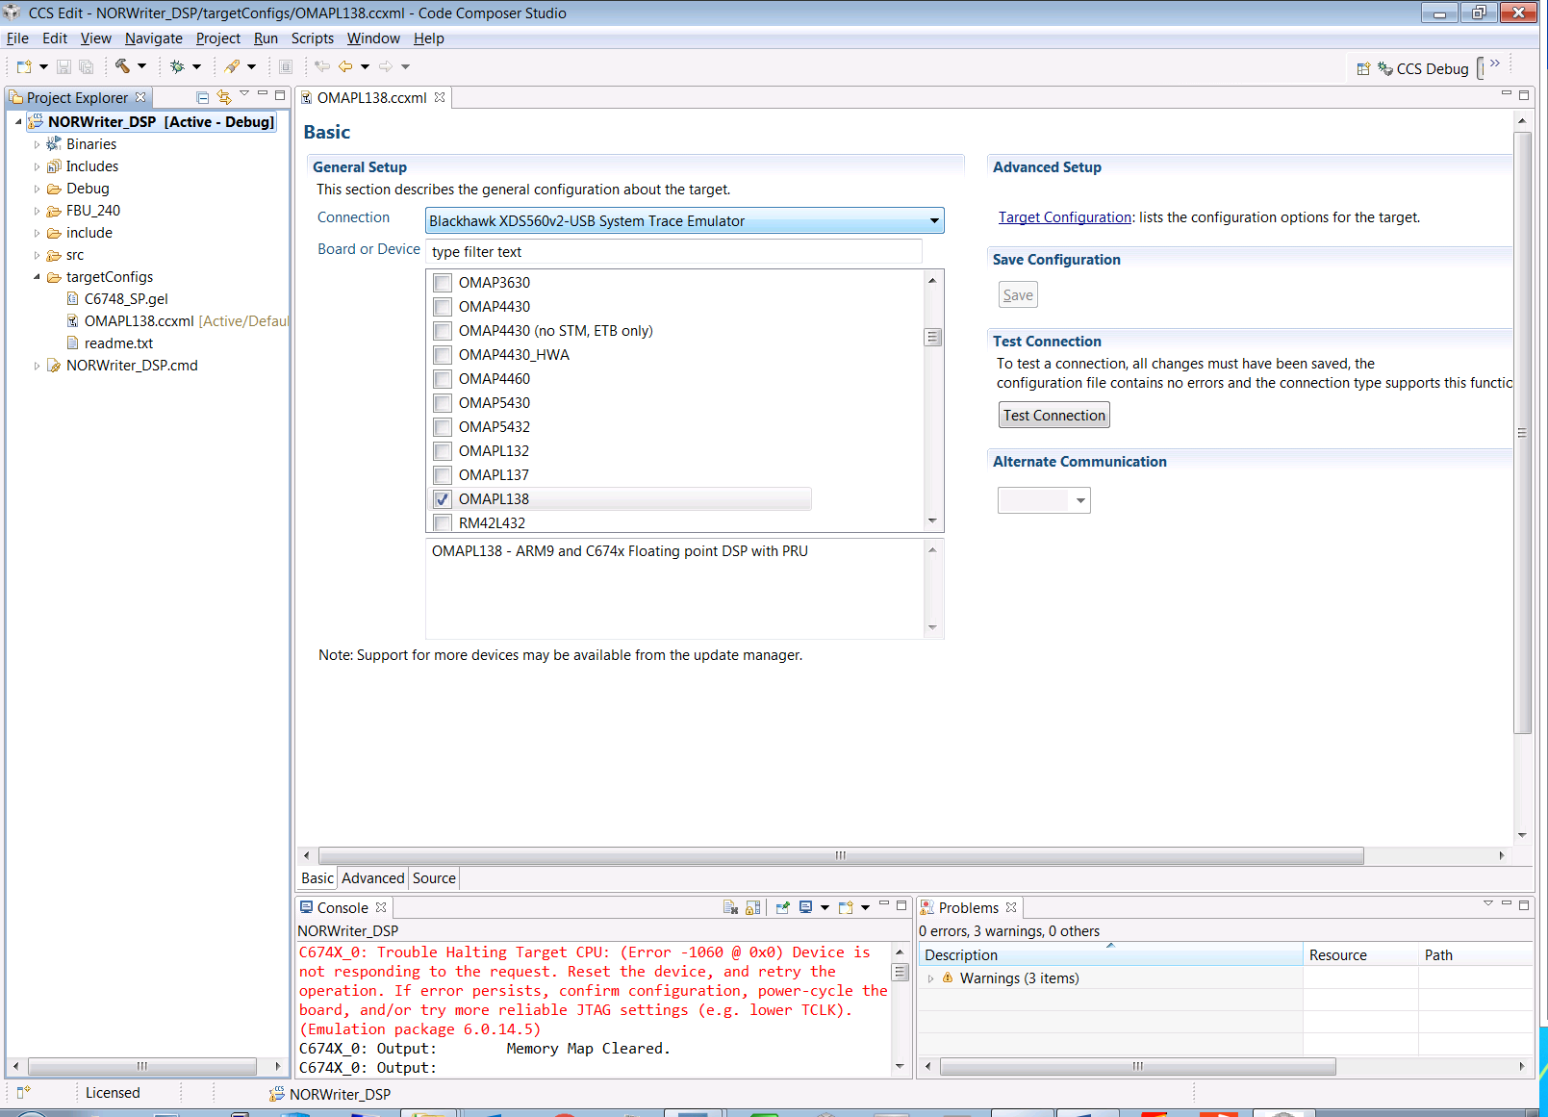

*Select Target Configuration : All Connections : C674X_0 and confirm the CPU properties field*

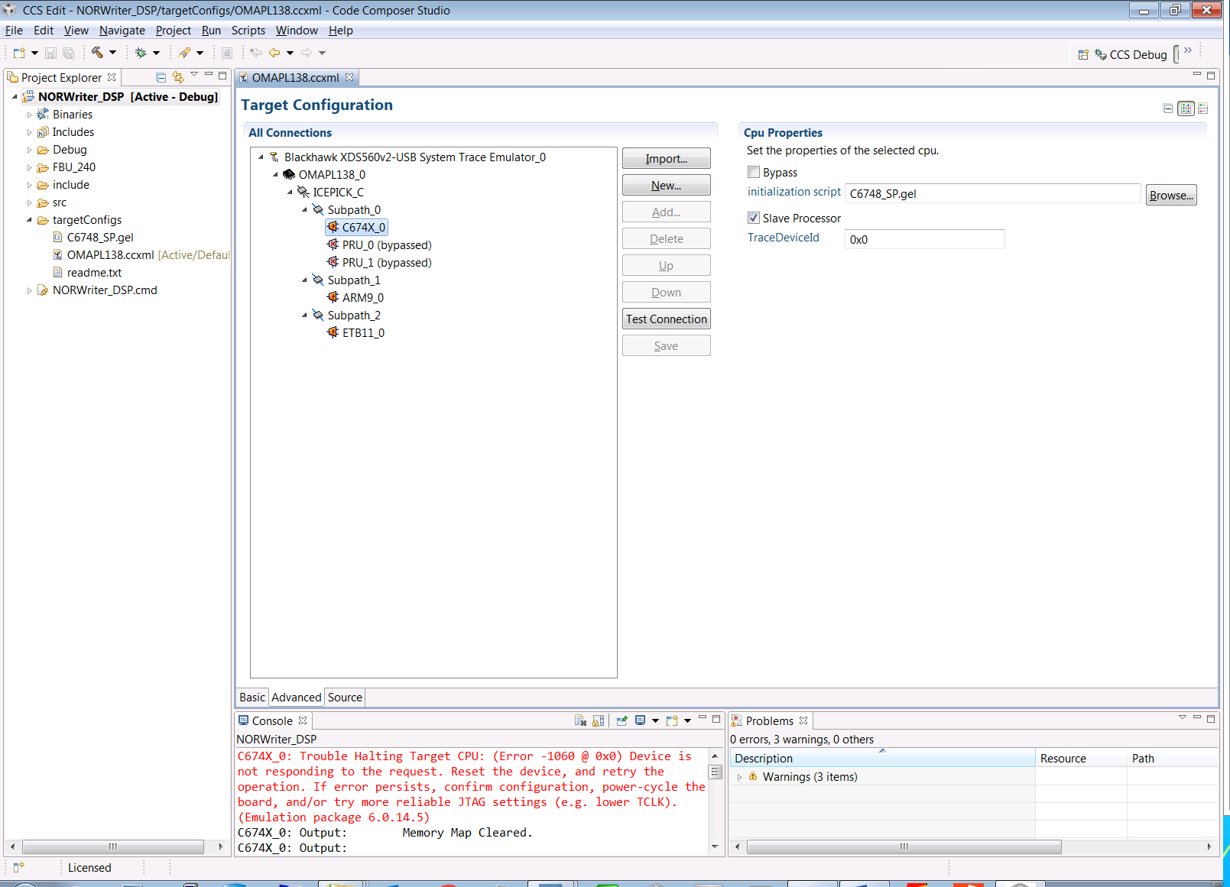

*Select Target Configuration : All Connections : ARM9_0 and confirm the CPU properties field*

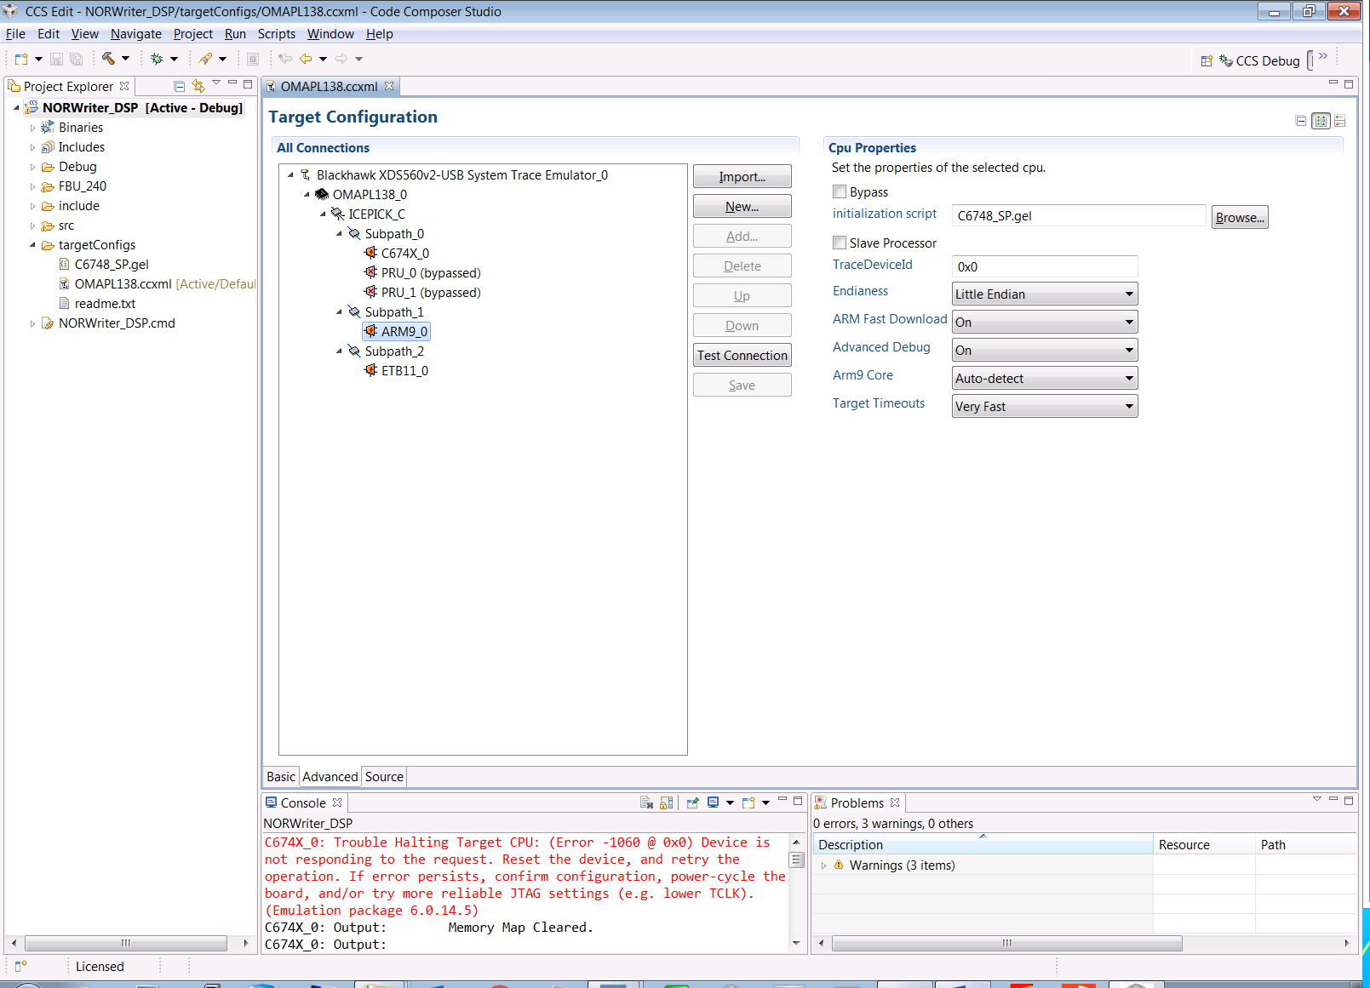

*Bypass the PRUs will make debugging simpler by eliminating them from the debug session.*

*Select the Save Button to commit your changes.*

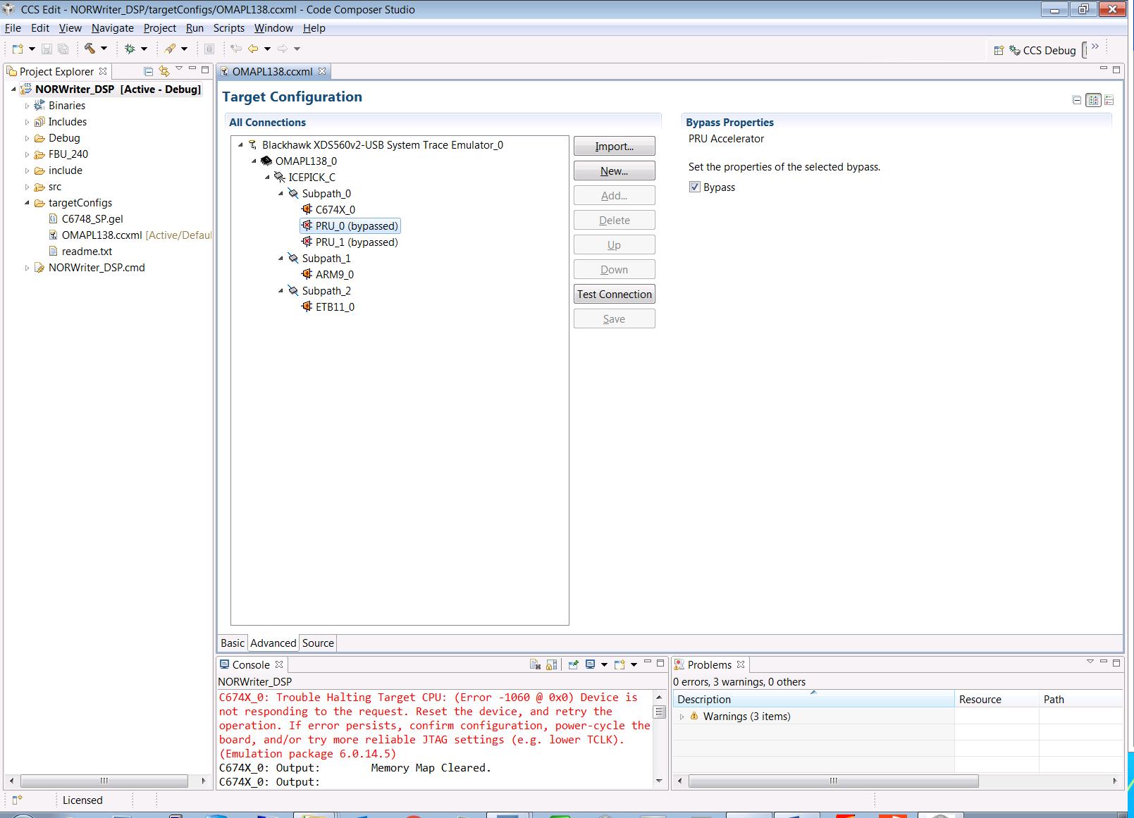

1. Version Listing

| **Originator / Rev. Date** | **Reason for Change** | **Description of Change** | **Rev.** |
| --- | --- | --- | --- |
| KJS 2017/05/18 | Initial Release | Initial Firmware Release for Risk Reduction Flight | A |
| KJS 2017/05/23 2017/06/01 | Risk Reduction Flight #2 | Incorporate 2nd Platform group. Updated OMAP Version number  Updated OFP Image version number | B |
| WDH 2017/07/06 | Additional Features and Bug Fixes | Incorporate updates to CI Task and BIT Task. Includes additional features and Bug Fixes | C |